**Aim:**  To implement Area Filling Algorithm: Boundary Fill, Flood Fill.

**Objective:**

Polygon is an ordered list of vertices as shown in the following figure. For filling polygons with particular colors, we need to determine the pixels falling on the border of the polygon and those which fall inside the polygon. Objective is to demonstrate the procedure for filling polygons using different techniques.

**Theory:**

**1) Boundary Fill algorithm –**

Start at a point inside a region and paint the interior outward toward the boundary. If the boundary is specified in a single color, the fill algorithm processed outward pixel by pixel until the boundary color is encountered. A boundary-fill procedure accepts as input the coordinate of the interior point (x, y), a fill color, and a boundary color.

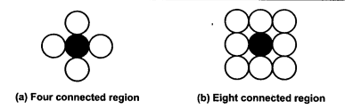

**Procedure:**

boundary_fill (x, y, f_color, b_color)

{

if (getpixel (x, y) != b_colour && getpixel (x, y) != f_colour)

{

putpixel (x, y, f_colour)

boundary_fill (x + 1, y, f_colour, b_colour);

boundary_fill (x, y + 1, f_colour, b_colour);

boundary_fill (x - 1, y, f_colour, b_colour);

boundary_fill (x, y - 1, f_colour, b_colour);

}

}

**Program:**

#include<stdio.h>

#include<conio.h>

#include<graphics.h>

void bf(int,int,int,int);

void main()

{

int gd=DETECT,gm;

initgraph(&gd,&gm,"C:\\TURBOC3\\BGI");

rectangle(50,50,100,100);

bf(70,70,10,15);

getch();

closegraph();

}

void bf(int x,int y,int fcolor,int bcolor)

{

int ccolor=getpixel(x,y);

if((ccolor!=fcolor)&&(ccolor!=bcolor))

{

putpixel(x,y,fcolor);

bf(x,y-1,fcolor,bcolor);

bf(x,y+1,fcolor,bcolor);

bf(x+1,y,fcolor,bcolor);

bf(x-1,y,fcolor,bcolor);

}

}

**Output:**



**2) Flood Fill algorithm –**

Sometimes we want to fill an area that is not defined within a single color boundary. We paint such areas by replacing a specified interior color instead of searching for a boundary color value. This approach is called a flood-fill algorithm.

1. We start from a specified interior pixel (x, y) and reassign all pixel values that are currently set to a given interior color with the desired fill color.

2. If the area has more than one interior color, we can first reassign pixel values so that all interior pixels have the same color.

3. Using either 4-connected or 8-connected approach, we then step through pixel positions until all interior pixels have been repainted.

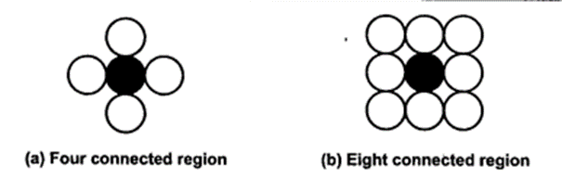

**Procedure -**

flood_fill (x, y, old_color, new_color)

{

if (getpixel (x, y) = old_colour)

{

putpixel (x, y, new_colour);

flood_fill (x + 1, y, old_colour, new_colour);

flood_fill (x - 1, y, old_colour, new_colour);

flood_fill (x, y + 1, old_colour, new_colour);

flood_fill (x, y - 1, old_colour, new_colour);

flood_fill (x + 1, y + 1, old_colour, new_colour);

flood_fill (x - 1, y - 1, old_colour, new_colour);

flood_fill (x + 1, y - 1, old_colour, new_colour);

flood_fill (x - 1, y + 1, old_colour, new_colour);

}

}

**Program:**

#include<stdio.h>

#include<conio.h>

#include<graphics.h>

void ff(int,int,int,int);

void main()

{

int gd=DETECT,gm;

initgraph(&gd,&gm,"C:\\TURBOC3\\BGI");

rectangle(50,50,100,100);

ff(70,70,0,15);

getch();

closegraph();

}

void ff(int x,int y,int ocolor,int ncolor)

{

if(getpixel(x,y)==ocolor)

{

putpixel(x,y,ncolor);

delay(5);

ff(x,y-1,ocolor,ncolor);

ff(x,y+1,ocolor,ncolor);

ff(x+1,y,ocolor,ncolor);

ff(x-1,y,ocolor,ncolor);

}

}

**Output:**



**Conclusion:** Comment on

1. **Importance of Flood fill**:The flood fill algorithm is crucial for automating color replacement and region filling tasks in areas like computer graphics, image editing, and gaming, streamlining processes and enhancing efficiency.
2. **Limitation of methods:**Flood fill's limitations encompass possible bleeding beyond boundaries due to irregular pixels, and difficulty in accurately identifying enclosed regions in complex images. However, meticulous implementation can mitigate these issues, ensuring its effectiveness in diverse applications.
3. **Usefulness of method**:The flood fill method is highly valuable for its seamless color replacement and region filling capabilities, proving essential in image editing, graphics design, and gaming by enhancing efficiency and creativity.